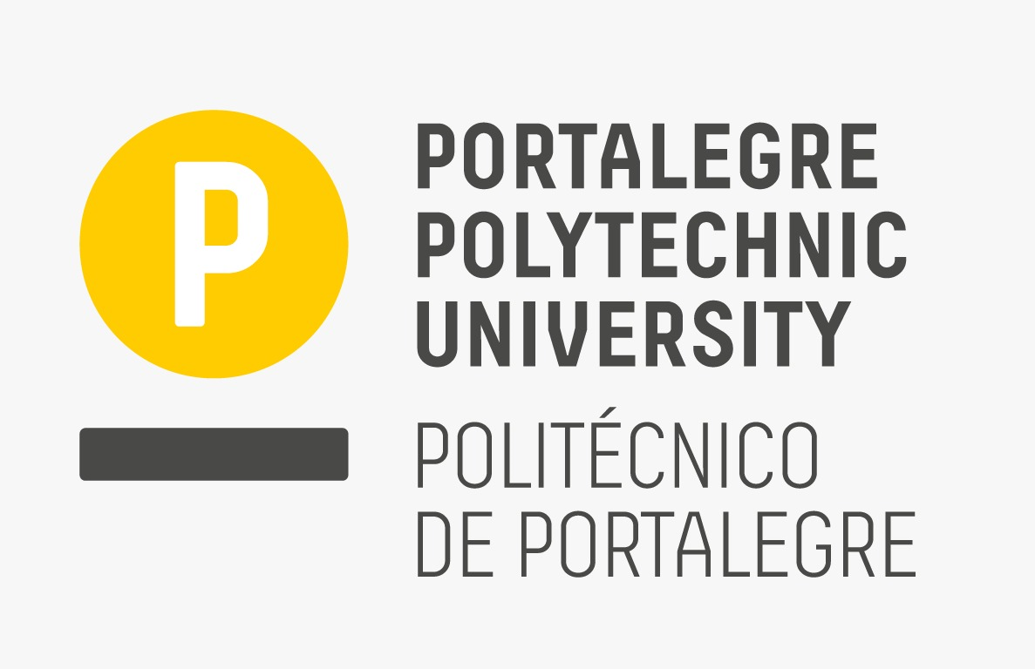

ICDAM-2024
5th International Conference on Data Analysis and Management

Organized by London Metropolitan University, London, UK (Venue Partner)

in association with

WSG University, Bydgoszcz, Poland, Europe

&

Portalegre Polytechnic University, Portugal, Europe

&

BPIT, GGSIPU, Delhi

Date: 14th - 15th June 2024

********** CALL FOR WORKSHOP PAPERS ***********

INTERNATIONAL WORKSHOP ON
[Insert Workshop Session Name]

WORKSHOP ORGANIZERS:
[Name, University or Organization, Country, e-mail]

EDITORIAL BOARD: (Optional)
[Name, University or Organization, Country, e-mail]

WORKSHOP DESCRIPTION:
[Insert descriptive paragraph]

RECOMMENDED TOPICS:
Topics to be discussed in this special session include (but are not limited to) the following:

- [Please insert a minimum of 6 topics]

SUBMISSION PROCEDURE:
You need to create your own submission system (either use easychair or any other standard submission system) and all the submissions must be original and may not be under review by another publication. INTERESTED AUTHORS SHOULD CONSULT THE CONFERENCE’S GUIDELINES FOR MANUSCRIPT SUBMISSIONS at https://icdam-conf.com/. All submitted papers will be reviewed on a double-blind, peer review basis.

TENTATIVE LIST OF POTENTIAL CONTRIBUTORS:
Please list the tentative/confirmed contributors [Minimum 10 with name, affiliation, and email] who will submit their paper in the workshop.

LEAD WORKSHOP ORGANIZER:
[Name, University or Organization, Country, e-mail]
*If more than one workshop organizers
* * * * * *

